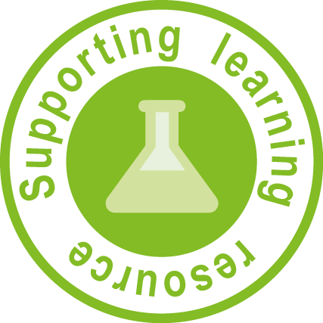

Indigenous knowledge for disaster risk reduction: Teacher note

A group of people is considered indigenous when they belong to, or originate from, a particular area or country. For example, Aboriginal peoples and Torres Strait Islander peoples are indigenous to Australia; Maori people are indigenous to New Zealand.

Many indigenous peoples around the world have strong traditions of oral storytelling as means of handing on the knowledge gained while living in an area for many generations. Many indigenous groups around the world have developed oral histories (folklore, stories or beliefs) that have been passed down from generation to generation, including oral histories on geological events.

The sheet How indigenous knowledge is used for disaster risk reduction allows students to read articles and explore ways in which some indigenous people of Asia share knowledge of earthquakes and tsunamis and how knowing oral histories helps with disaster preparation.

A selection of articles about how indigenous knowledge is used by communities around the world has been gathered together in the sheet Extracts from: Indigenous knowledge for disaster risk reduction: Good practices and lessons learned from experiences in the Asia-Pacific region.

When modelling to the students how to analyse the articles in the sheet:
- use pages 52–54
- read the title and identify how it includes the city and the natural disaster the city experiences
- direct students to skim the ‘Abstract’ and ‘Background’
- instruct students to read:
- story/event
- indigenous knowledge
- lessons learned
- discuss with class how to complete the questions on the worksheet.

Groups will require access to specific information from the following sections in the booklet:
- Meyers, K and Watson, P 2008, Legend, ritual and architecture on the ring of fire, pp. 17–22.

Note: This article could be used for several pairs of students. The article shares a story/event but then looks at the indigenous knowledge and lessons learned from three islands in the area.
- Cerdena, G, 2008, Indigenous know-how on Mayon Volcano’s lava-spittle mysticism, pp. 55–58
- McAdoo, B G, Baumwoll, J and Moore, A 2008, Indigenous knowledge saved lives during 2007 Solomon Islands Tsunami, pp. 64–67
- Arunotai, N, 2008, Saved by an old legend and a keen observation: the case of Moken sea nomads in Thailand, pp. 73–78

The class can then be divided into groups with each group looking at a different article. When choosing an article and creating student groups for this activity, consider students’ reading ability. Remind students to read everything, except the ‘Abstract’ and ‘Background’ which may be skimmed.

After reading each section, instruct students to answer the questions on the sheet.

When sheets have been completed, groups can present information about the group they researched to the rest of the class. Students should be encouraged to identify aspects of stories that are similar across different cultures.
A mapping site or program such as the website Google maps (Google) http://maps.google.com/ can be used.

